MO-SMS (Mobile-Originated)

📤 What Is MO-SMS (Mobile-Originated SMS)?
# Source: AI Source: Provided by: [Data Path: Persons Table -> ID Column: 1, Name_En Column: Motasem Essam] -> From: [Chatgpt (GPT‑5 Mini)] on [1/21/2026]
MO-SMS stands for Mobile-Originated Short Message Service.
It refers to an SMS that is sent from a mobile device (user) to the network or an external system (like another user or an application).
🧠 It’s called "originated" because the message originates from the user’s mobile phone.

📲 Example Scenarios:
# Source: AI Source: Provided by: [Data Path: Persons Table -> ID Column: 1, Name_En Column: Motasem Essam] -> From: [Chatgpt (GPT‑5 Mini)] on [1/21/2026]
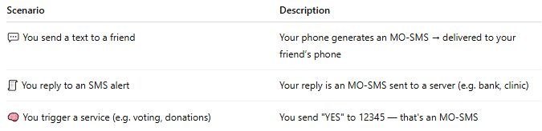

Scenario | Description
💬 You send a text to a friend | Your phone generates an MO-SMS → delivered to your friend’s phone
🧾 You reply to an SMS alert | Your reply is an MO-SMS sent to a server (e.g. bank, clinic)
🧠 You trigger a service (e.g. voting, donations) | You send "YES" to 12345 — that's an MO-SMS

🧩 MO-SMS Flow (Simplified):
# Source: AI Source: Provided by: [Data Path: Persons Table -> ID Column: 1, Name_En Column: Motasem Essam] -> From: [Chatgpt (GPT‑5 Mini)] on [1/21/2026]
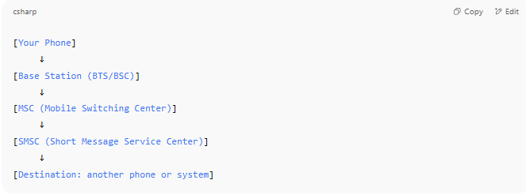

[Your Phone]
↓
[Base Station (BTS/BSC)]
↓
[MSC (Mobile Switching Center)]
↓
[SMSC (Short Message Service Center)]
↓
[Destination: another phone or system]

🔍 Technical Notes:
# Source: AI Source: Provided by: [Data Path: Persons Table -> ID Column: 1, Name_En Column: Motasem Essam] -> From: [Chatgpt (GPT‑5 Mini)] on [1/21/2026]
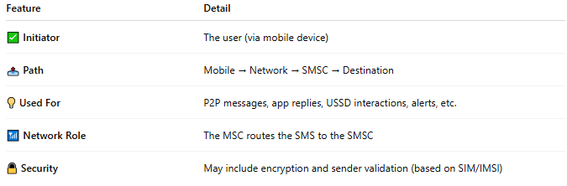

Feature | Detail
✅ Initiator | The user (via mobile device)
📤 Path | Mobile → Network → SMSC → Destination
💡 Used For | P2P messages, app replies, USSD interactions, alerts, etc.
📶 Network Role | The MSC routes the SMS to the SMSC
🔒 Security | May include encryption and sender validation (based on SIM/IMSI)

🆚 MO-SMS vs MT-SMS:
# Source: AI Source: Provided by: [Data Path: Persons Table -> ID Column: 1, Name_En Column: Motasem Essam] -> From: [Chatgpt (GPT‑5 Mini)] on [1/21/2026]
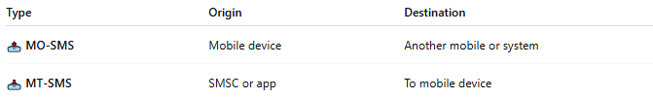

Type | Origin | Destination
📤 MO-SMS | Mobile device | Another mobile or system
📥 MT-SMS | SMSC or app | To mobile device

📖 Summary:
# Source: AI Source: Provided by: [Data Path: Persons Table -> ID Column: 1, Name_En Column: Motasem Essam] -> From: [Chatgpt (GPT‑5 Mini)] on [1/21/2026]
- MO-SMS = Text sent from your phone
- It starts at the mobile device and moves through the network
- Used in person-to-person messaging, responses to A2P, and SMS-based services

